## **Linux Commands and execution on the terminal**

* **Mkdir, cd, ls, touch and Grep**

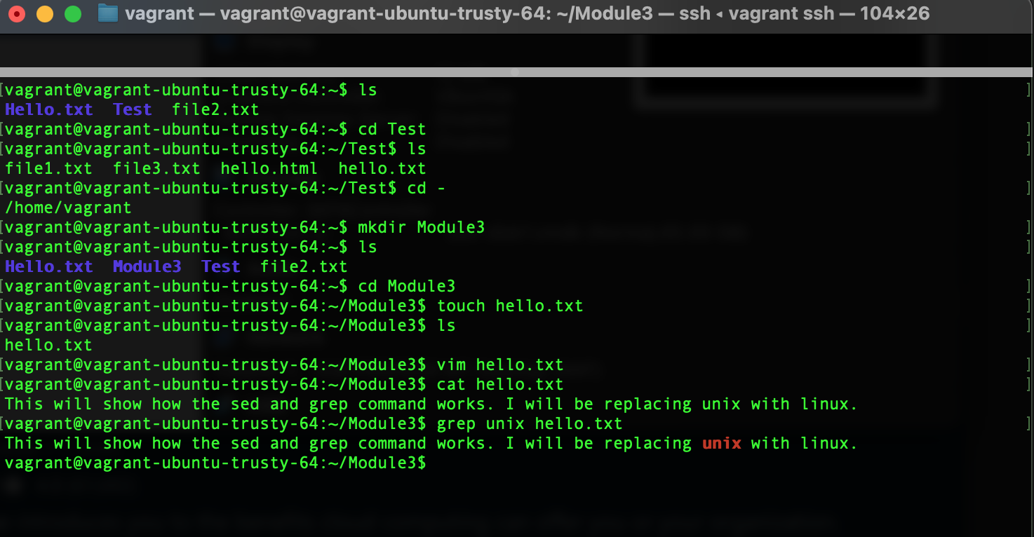

* **sed**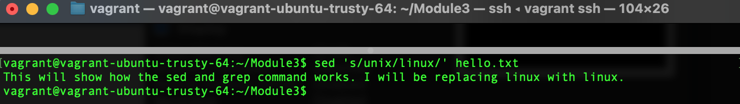
* **wc**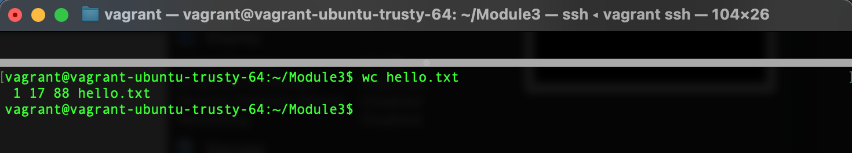
* **cat**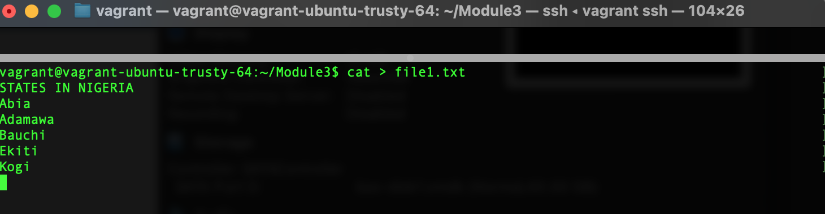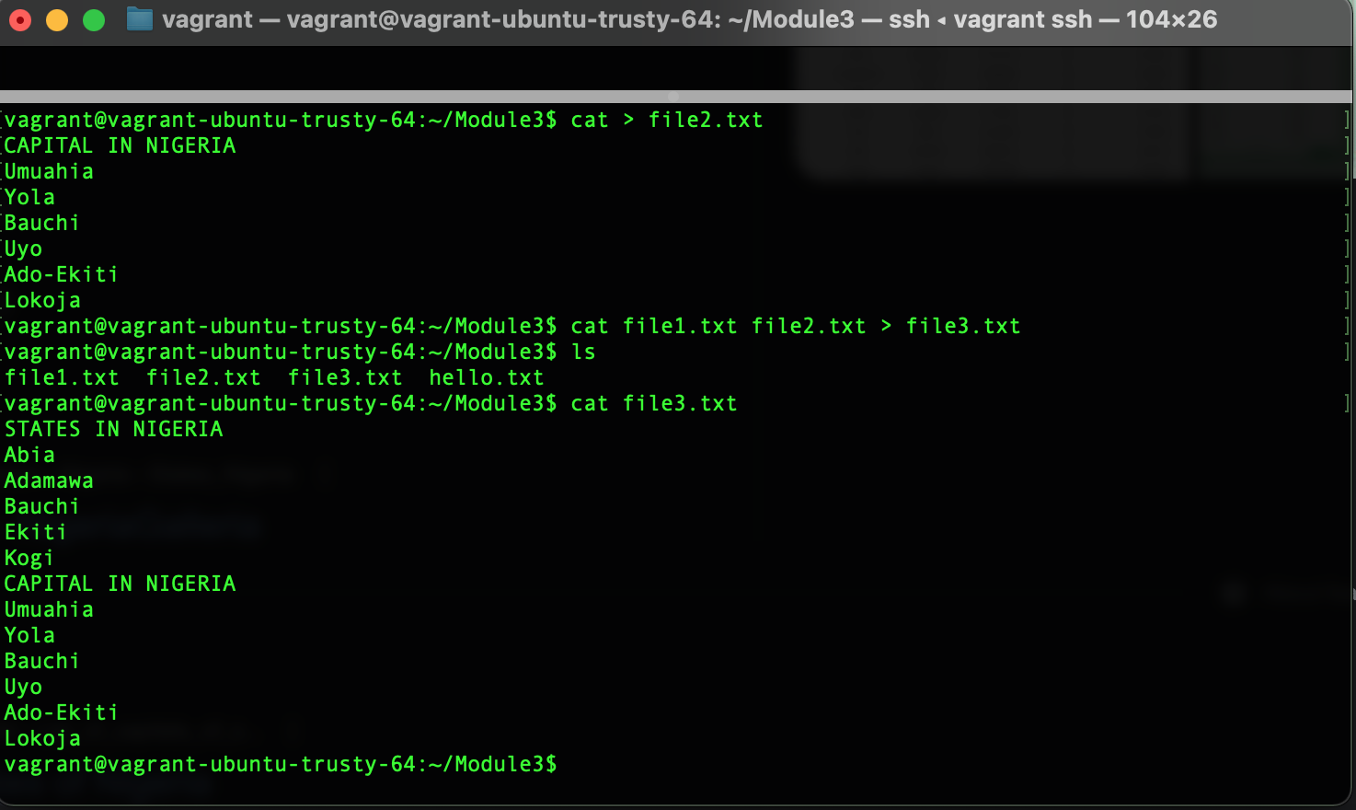
* **echo**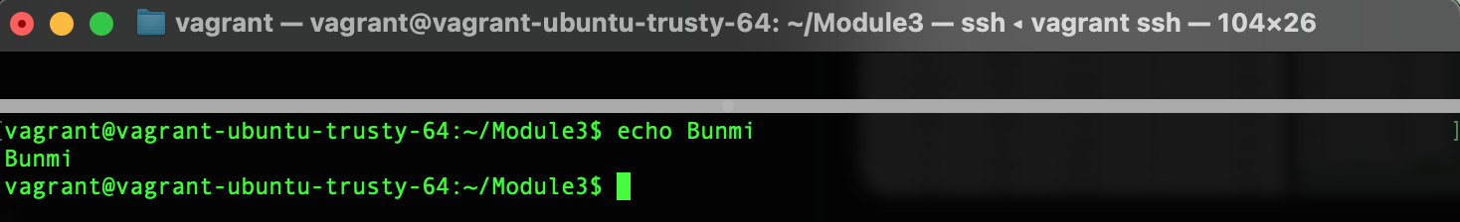
* **ps**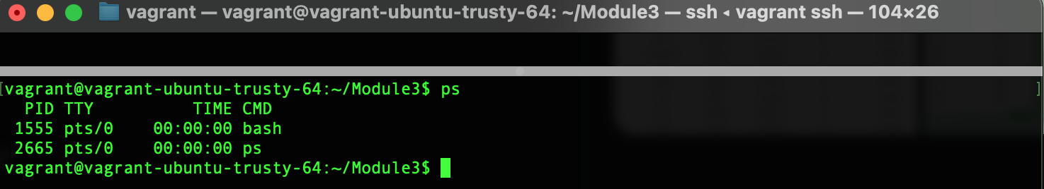
* **cp**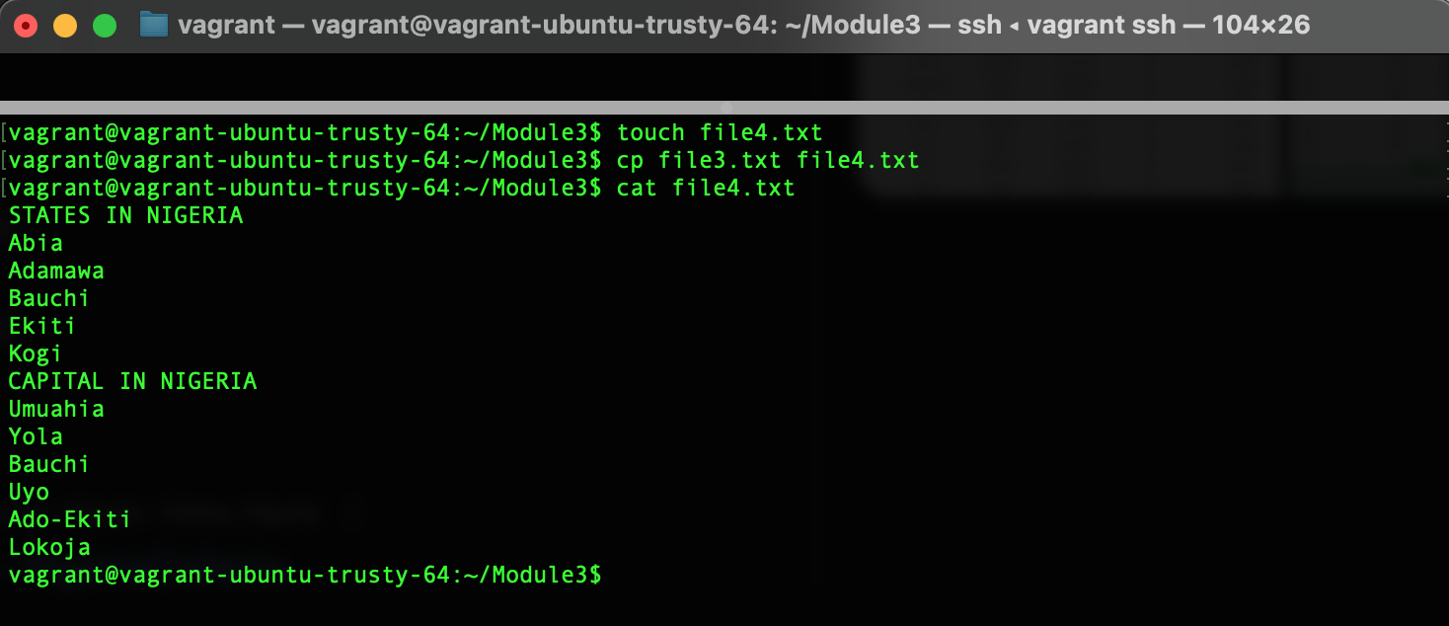
* **mv**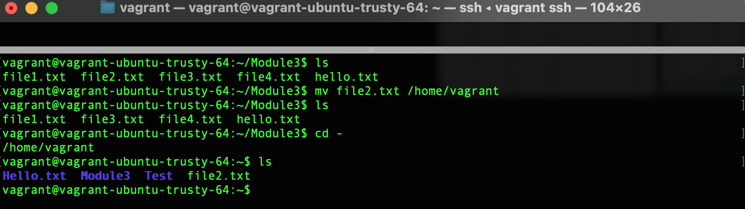
* **lsof**